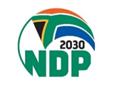
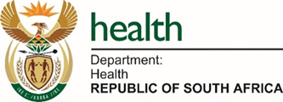

Stakeholder Engagement Meeting
on the
Elimination of Cervical Cancer in South Africa: A Strategic and Implementation Framework 2026 – 2030

Facilitator Pack: Group Discussions Worksheets
Panel 3: Key Aspects of Secondary Prevention – Screening and Treatment of Precancerous Lesions
Anchor Interventions
- Thermal ablation scale-up as primary modality
- Task-shifting to WBOCOT lay counselors and PNs
- Decentralization to PHC, CHCs and district hospitals
- Standardized national SOPs and algorithms
- Equipment, procurement, deployment and maintenance

Key Discussion Questions
- Is a thermal ablation–first approach feasible across all facility types?
- Are national SOPs consistently implemented?
- What is the weakest link in the treatment pathway?

Points of Diversion
- TA vs LLETZ mix in rural and urban settings
- Equipment uptime and maintenance accountability
- Use of staging data for planning and costing

Panel Outputs
- Recommended treatment scale-up model
- Strategies to address 2x key costing or resource assumptions
- Suggest 1x system reform required
- Policy reform for decentralization / task-sharing and integration

