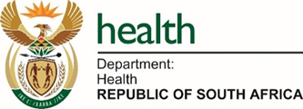


Stakeholder Engagement Meeting
on the
Elimination of Cervical Cancer in South Africa: A Strategic and Implementation Framework 2026 – 2030

Facilitator Pack: Group Discussions Worksheets

Panel 1: Confronting Barriers and Facilitators of HPV Vaccination Uptake

Anchor Interventions
- Scale-up routine HPV vaccination (9–15 years)
- Catch-up vaccination (9–24 years; 2 doses for HIV-positive girls)
- Expanded target populations
- Social mobilization to address hesitancy

Key Discussion Questions
- Which population groups remain unreached despite current delivery models?
- Are catch-up strategies operationally and financially viable at scale?
- How effectively are HIV services integrated into HPV vaccination delivery?
- What policy changes are needed to reach unreached girls in and out of schools?

Points of Diversion
- DoH–DBE accountability gaps
- Risks and safeguards related to single-dose policy
- Need for ring-fence and improve allocation on the HPV financing

Panel Outputs
- Strategies to address the Top 3 barriers to achieving 90% coverage for vaccination
- Suggested 2 x vaccination delivery model adaptations / 1 national policy or financing action

