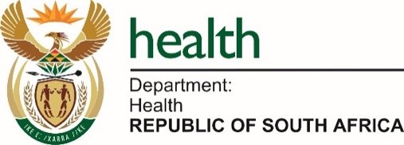
Stakeholder Engagement Meeting
on the
Elimination of Cervical Cancer in South Africa: A Strategic and Implementation Framework 2026 – 2030

Group Discussions Guide

Theme | Facilitator | Scribe
Panel Discussion 1: Confronting Barriers and facilitators of HPV vaccination uptake | - Dr Amanda Rozani, DBE  - Prof Sinead Delany-Moretlwe, WRHI | Ms Phuti Mashiane  Mr Mandla Tshabalala
Panel Discussion 2: Supporting the elimination of cervical cancer through an integrated approach to screening | - Dr Sithembile Dlamini-Nqeketo, WHO  - Dr Bulelani Kuwe, HST | Ms Neo Masike  Ms Mapula Pilosa  Mr Bezweni Ntuli
Panel Discussion 3: Discussing key aspects to Secondary Prevention (Screening & Treatment of Pre-Cancer Lesions) for Cervical Cancer Elimination | - Prof Motshedisi Sebitloane, UKZN  - Dr Madondo, ECDoH  - Prof Mike Sathekge, Steve Biko | Ms Victoria Magomani  Ms Joyce Mahutsi  Mr Siyabonga Mdiniso
Panel Discussion 4: Advancing multidisciplinary approach to effective management and care of women with invasive cancer | - Dr F Komane, NW  - Dr Joseph K. Mwangi, WHO | Ms Tendani Dladlama  Ms Elizabeth Maseti  Ms Noko Sethosa
Panel Discussion 5: Integrating Essential Package of Palliative Care for Cervical Cancer | - Mpho Ratshikana, Wits  - Professor Rene Krause, UCT | Ms Nocawe  Ms Lufuno Malala  Ms Fikile Mkhwanazi
Panel Discussion 6: Addressing structural, social, and technological approaches to strengthen health system integration, sustainable financing, political will, community engagement, and addressing inequities | - Ms Gugu Shabangu, NDoH  - Dr Nombuso Madonsela, AIDS Healthcare Foundation | Ms Kulani Khosa  Ms H Nenzhelele  Ms Sisanda Mtatambi

