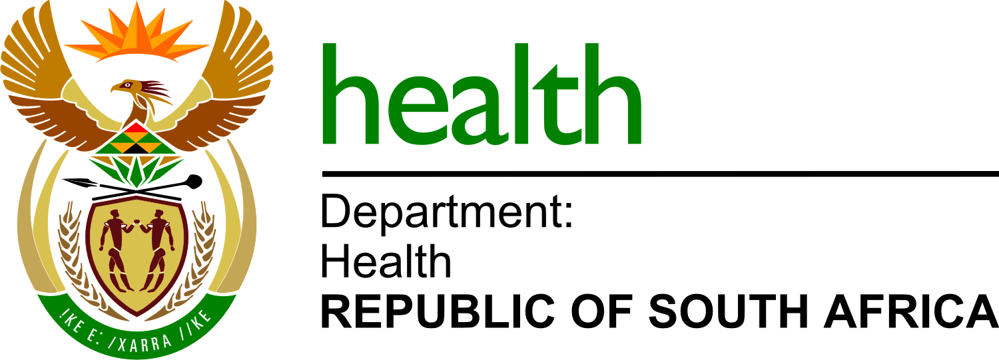

Reference No:

NDOH
28

202
3
/2024

Enquiries:

NDOH

Email
:

tenders@health.gov.za

CANCELLATION NOTICE: TENDER NDOH 28-2023/2024

BID NUMBER | TENDER DESCRIBTION | STATUS | REASON FOR CANCELLATION
NDOH 28-2023/2024 | APPOINTMENT OF A SERVICE PROVIDER TO SUPPLY, DELIVER AND DISTRIBUTE BASIC LIFE SUPPORT (BLS) ESSENTIAL EQUIPMENT AND TRAINING MANUALS FOR THE NATIONAL DEPARTMENT OF HEALTH. | CANCELLED | NON-RESPONSIVE BID RECEIVED.

