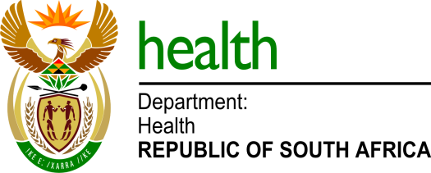

MEDIA ADVISORY

To: Editors & Health Journalists
Issued by: Department of Health
Date: Friday, 22 March 2024

Department holds TB Symposium on new technological developments in the management and treatment of TB patients in SA

Pretoria: The Department of Health will tomorrow (Saturday, 23 March) convene a TB Symposium to discuss amongst other things, the evolution of tuberculosis treatment and its impact on the country`s response to the epidemic, and the emergence of Bedaquiline resistance and mitigation factors.

South Africa is amongst the leading countries worldwide which introduced innovative interventions in response to the burden of this killer disease, and this has had a significant impact on the global policy on TB.

The gathering takes place a day before the national World TB Day commemoration, and will also reflect on the achievements made and new technological developments introduced in the management and treatment of TB patients. This follows the introduction of BPaL-L 6-month treatment regimen for DR-TB patients in the country last year.

This hybrid seminar will be attended by 500 local and international public health experts, as well as representatives of the medical schemes and pharmaceutical industry. Minister of Health, Dr Joe Phaahla will deliver a keynote address.

Members of the media are invited to attend symposium scheduled as follows:

Date: Saturday, 23 March 2024
Time: 09:00 – 12:00
Venue: Radisson Blue Hotel, Rivonia Road/ Daisy Street, Sandton

For more information and media enquiries, please contact:

Mr Foster Mohale
Health Departmental Spokesperson
072 432 3792/ foster.mohale@health.gov.za

Mr Doctor Tshwale
Media Liaison Officer for Health Minister
063 657 8487 / doctor.tshwale@health.gov.za

