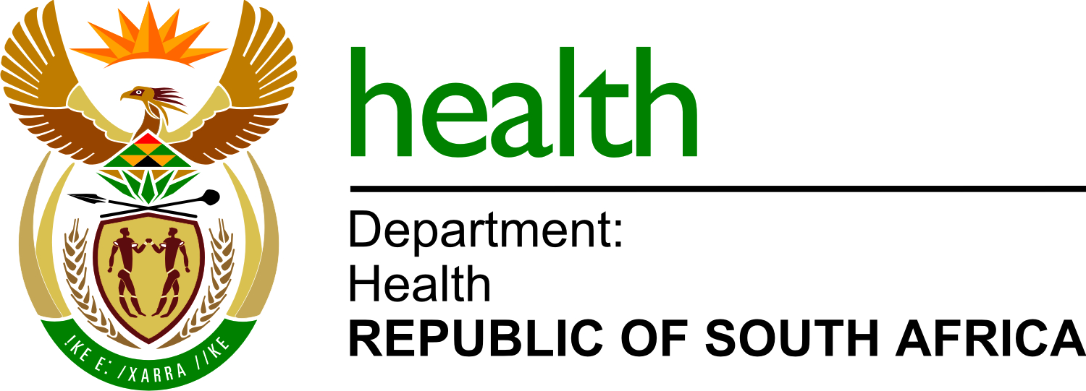
List of bidders
Bid Number | NDOH 13 / 2021-22
Request for appointment to serve as a Sub Recipient (SR) for the National Department of Health Global Fund TB/HIV Program from April 2021- March 2025
Number | Bidder Name
1 | Aurum Institute
2 | Tholwana e molemo
3 | Isibani Development
4 | Songe Social Change
5 | Think TB and HIV Net
6 | Lisebanzi Foundation
7 | Aquity Innovation
8 | Institute for health and sysm
9 | Vuyokazi
10 | Kgorogo Social Investments
11 | Show me your Number HIV prevention
12 | Centre for Communication
13 | TB and HIV CARE

