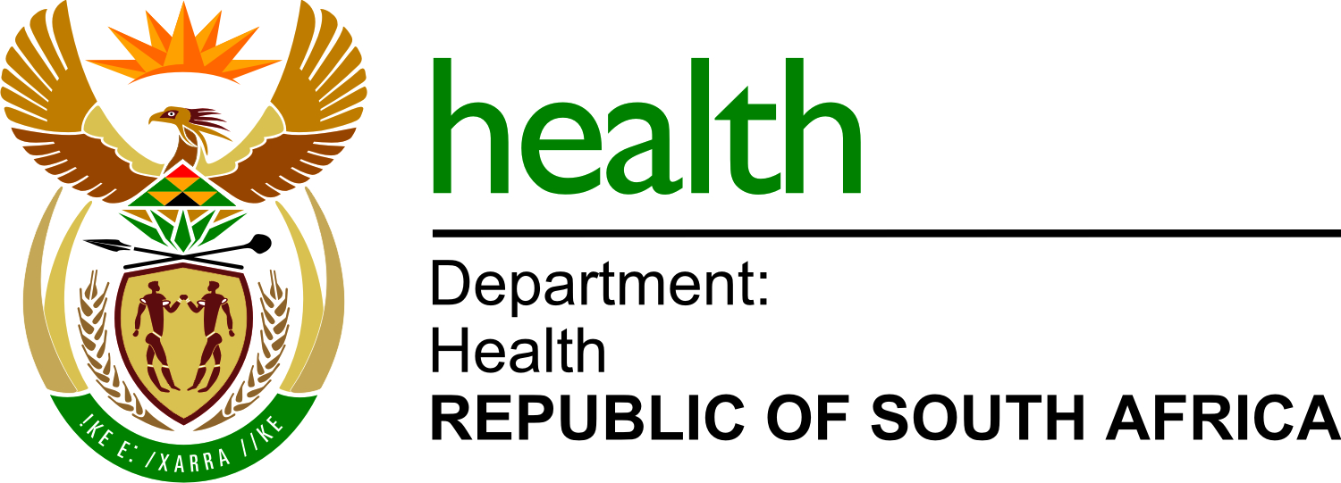

THE DIRECTOR-GENERAL

REQUEST THE DIRECTOR-GENERAL

BID NUMBER | BID DISCRIPTION | STATUS | REASON
NDOH 08/2021-2022 | APOINTMENT OF A SERVICE PROVIDER FOR SECURITY SYSTEM (OPERATING LEASE OF SECURITY SYSTEM) FOR NATIONAL DEPARTMENT OF HEALTH FOR A PERIOD OF 48 MONTHS | CANCELLED | NON-RESPONSIVE BIDS RECEIVED

